Pseudo inverse

Intro

The psuedo inverse of $$A$$ behaves like the inverse of $$A$$ except that it applies to non-invertible matrix $$A$$.

Property

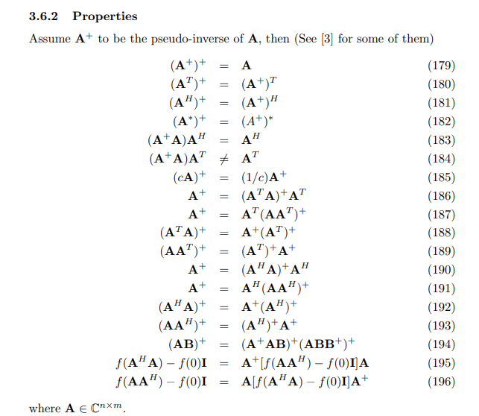

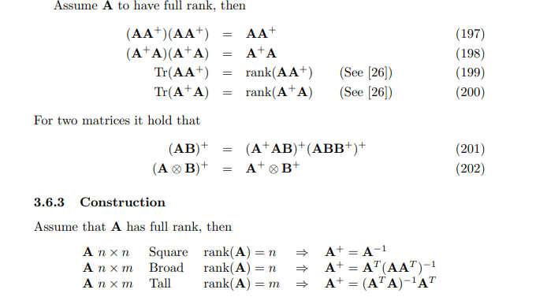

Proof of Property

For eq (179), skip

For eq (180),

$${\left(A^{T}\right)}^{+}A^{T}$$ = $$I_{m,n}$$

=> $${\left({\left(A^{T}\right)}^{+}A^{T}\right)}^{T}$$ = $$I_{m,n}^{T}$$

=> $${\left(A^{T}\right)}^{T}{\left({\left(A^{T}\right)}^{+}\right)}^{T}$$ = $$I_{m,n}^{T}$$

=> $$A{\left({\left(A^{T}\right)}^{+}\right)}^{T}$$ = $$I_{m,n}^{T}$$

=> $$A^{+}A{\left({\left(A^{T}\right)}^{+}\right)}^{T}$$ = $$A^{+}I_{m,n}^{T}$$ = $$A^{+}$$

=> $${\left({\left(A^{T}\right)}^{+}\right)}^{T}$$ = $$A^{+}$$

=> $${\left({\left({\left(A^{T}\right)}^{+}\right)}^{T}\right)}^{T}$$ = $${\left(A^{+}\right)}^{T}$$

=> $${\left(A^{T}\right)}^{+}$$ = $${\left(A^{+}\right)}^{T}$$

For eq (181), do similar thing as eq(180).

For eq (182), do similar thing as eq(180).

For eq (183),

since

$$\left(A^{+}\right)A$$ = $$I_{m,n}$$

NOTE that

$$\left(A^{+}A\right)A^{T}$$ is not equivalent to $$A^{T}$$

For eq (185),

$${\left(cA\right)}^{+}\left(cA\right)$$ = $$I_{m,n}$$

=> $$c{\left(cA\right)}^{+}A$$ = $$I_{m,n}$$

=> $${\left(cA\right)}^{+}A$$ = $$\frac{1}{c}I_{m,n}$$

=> $${\left(cA\right)}^{+}=\frac{1}{c}I_{m,n}A^{+}$$

=> $${\left(cA\right)}^{+}=\frac{1}{c}A^{+}$$

For eq (186),

$$A^{+}A$$ = $$I_{m,n}$$

=> $${\left(A^{+}A\right)}^{T}$$ = $$I_{m,n}^{T}$$

=> $$A^{T}{\left(A^{+}\right)}^{T}$$ = $$I_{m,n}^{T}$$

=> $$A^{T}{\left(A^{T}\right)}^{+}$$ = $$I_{m,n}$$

=> $$\left(AA^{T}\right){\left(AA^{T}\right)}^{+}$$ = $$I_{m,n}$$

=> $$\left(AA^{T}\right){\left(A^{T}\right)}^{+}A^{+}$$ = $$I_{m,n}$$

=> $$A^{+}$$ = $$\left(\left(AA^{T}\right){\left(A^{T}\right)}^{+}\right)I_{m,n}$$

=>

By definition, one has

$$A^{+}$$ = $$\frac{1}{2}\left(A+A^{T}\right)$$

Thus,

$${\left(A^{T}A\right)}^{+}$$ = $$\frac{1}{2}\left(\left(A^{T}A\right)+{\left(A^{T}A\right)}^{T}\right)$$

=> $${\left(A^{T}A\right)}^{+}A^{T}$$ = $$\frac{1}{2}\left(A^{T}A+\left(A^{T}A\right)\right)A^{T}$$

= $$\frac{1}{2}\left(A^{T}AA^{T}+AA^{T}A^{T}\right)$$

=

For eq (187), do similar thing to eq (186).

For eq (188),

Since $$A^{T}A$$ is always symmetric,

one can consider psuedo inverse of $$A^{T}A$$ as inverse of $$A^{T}A$$.

$${\left(A^{T}A\right)}^{+}$$ = $${\left(A^{T}A\right)}^{−1}$$

=> $${\left(A^{T}A\right)}^{+}$$ = $$A^{−1}{\left(A^{T}\right)}^{−1}$$

=> $${\left(A^{T}A\right)}^{+}$$ = $${\left({\left(A^{−1}\right)}^{T}\right)}^{T}{\left(A^{−1}\right)}^{T}$$

Since $${\left({\left(A^{−1}\right)}^{T}\right)}^{T}{\left(A^{−1}\right)}^{T}$$ is always symmetric, it will become

$${\left(A^{T}A\right)}^{+}$$ = $${\left({\left(A^{−1}\right)}^{T}\right)}^{T}{\left(A^{−1}\right)}^{T}$$

=> $${\left(A^{+}A\right)}^{T}$$ = $${\left({\left(A^{+}\right)}^{T}\right)}^{T}{\left(A^{+}\right)}^{T}$$

=> $${\left(A^{+}A\right)}^{T}$$ = $$\left(A^{+}\right){\left(A^{+}\right)}^{T}$$

For eq (189), doing similar thing to eq (188)

For eq (190), doing similar thing to eq (186)

For eq (191), doing similar thing to eq (186)

For eq (192), doing similar thing to eq (188)

For eq (193), doing similar thing to eq (188)

For eq (194),

On the left-hand side,

$${\left(AB\right)}^{+}$$

= $$\frac{1}{2}\left(AB+{\left(AB\right)}^{T}\right)$$

= $$\frac{1}{2}\left(AB+B^{T}A^{T}\right)$$

On the right-hand side,

$${\left(A^{+}AB\right)}^{+}{\left(ABB^{+}\right)}^{+}$$

= $$\frac{1}{2}\left(A^{+}AB+{\left(A^{+}AB\right)}^{T}\right)⋅\frac{1}{2}\left(ABB^{+}+{\left(ABB^{+}\right)}^{T}\right)$$

= $$\frac{1}{2}\left(\frac{1}{2}\left(A+A^{T}\right)AB+{\left(\frac{1}{2}\left(A+A^{T}\right)AB\right)}^{T}\right)⋅\frac{1}{2}\left(AB⋅\frac{1}{2}\left(B+B^{T}\right)+{\left(AB⋅\frac{1}{2}\left(B+B^{T}\right)\right)}^{T}\right)$$

= $$\frac{1}{4}\left(\left(A+A^{T}\right)AB+{\left(\left(A+A^{T}\right)AB\right)}^{T}\right)⋅\frac{1}{4}\left(AB\left(B+B^{T}\right)+{\left(AB\left(B+B^{T}\right)\right)}^{T}\right)$$

= $$\frac{1}{16}\left(\left(A+A^{T}\right)AB+{\left(\left(A+A^{T}\right)AB\right)}^{T}\right)\left(AB\left(B+B^{T}\right)+{\left(AB\left(B+B^{T}\right)\right)}^{T}\right)$$

= $$\frac{1}{16}\left(AAB+A^{T}AB+B^{T}A^{T}{\left(A+A^{T}\right)}^{T}\right)\left(ABB+ABB^{T}+{\left(B+B^{T}\right)}^{T}BA\right)$$

= $$\frac{1}{16}\left(AAB+A^{T}AB+B^{T}A^{T}A^{T}+B^{T}A^{T}A\right)\left(ABB+ABB^{T}+B^{T}BA+BBA\right)$$

= $$\frac{1}{16}\left(A^{2}B+A^{T}AB+B^{T}{\left(A^{T}\right)}^{2}+B^{T}A^{T}A\right)\left(AB^{2}+ABB^{T}+B^{T}BA+B^{2}A\right)$$

= $$\frac{1}{16}\left[A^{2}BAB^{2}+A^{2}BABB^{T}+A^{2}BB^{T}BA+A^{2}BB^{2}A\right]$$

+ $$\frac{1}{16}\left[A^{T}ABAB^{2}+A^{T}ABABB^{T}+A^{T}ABB^{T}BBA+A^{T}ABB^{2}A\right]$$

+ $$\frac{1}{16}\left[B^{T}{\left(A^{T}\right)}^{2}AB^{2}+B^{T}{\left(A^{T}\right)}^{2}ABB^{T}+B^{T}{\left(A^{T}\right)}^{2}B^{T}BA+B^{T}{\left(A^{T}\right)}^{2}B^{2}A\right]$$

+ $$\frac{1}{16}\left[B^{T}A^{T}AAB+B^{T}A^{T}AABB^{T}+B^{T}A^{T}AB^{T}BA+B^{T}A^{T}ABBA\right]$$

= $$\frac{1}{16}\left[A^{2}BAB^{2}+A^{2}BABB^{T}+A^{2}BB^{T}BA+A^{2}B^{3}A\right]$$

+ $$\frac{1}{16}\left[A^{T}ABAB^{2}+A^{T}ABABB^{T}+A^{T}ABB^{T}B^{2}A+A^{T}AB^{3}A\right]$$

+ $$\frac{1}{16}\left[B^{T}{\left(A^{T}\right)}^{2}AB^{2}+B^{T}{\left(A^{T}\right)}^{2}ABB^{T}+B^{T}{\left(A^{T}\right)}^{2}B^{T}BA+B^{T}{\left(A^{T}\right)}^{2}B^{2}A\right]$$

+ $$\frac{1}{16}\left[B^{T}A^{T}A^{2}B+B^{T}A^{T}A^{2}BB^{T}+B^{T}A^{T}AB^{T}BA+B^{T}A^{T}AB^{2}A\right]$$

=



For eq (197),

Preface

I recommend you to browse and understand the proof of eq (199) first.

In eq (199), it has mentioned

$$P_{A}$$ = $$AA^{+}$$ = $$A{\left(A^{T}A\right)}^{−1}A^{T}$$

which is idemptotent I.e.

$$P_{A}$$ = $${\left(P_{A}\right)}^{k}$$ for any positive integer $$k$$.

Which completes the proof.

For eq (198), do similar things to eq (197).

For eq (199),

By eq in section 3.6.3 in cookbook, one has

$$A$$ has size $$n⋅m$$

=> $$A$$ is tall

=> $$A^{+}$$ = $${\left(A^{T}A\right)}^{−1}A^{T}$$

=> $$AA^{+}$$ = $${\left(A^{T}A\right)}^{−1}A^{T}$$

By property of trace of matrix, one also has

$$tr\left(AA^{+}\right)$$ = $$tr\left({\left(A^{T}A\right)}^{−1}A^{T}\right)$$ = $$rank\left(A\right)$$ = $$n$$

On the other hand, by property of $$A^{+}$$ (see the section 3.6 in cookbook)

$$A^{+}$$ = $$\frac{1}{2}\left(A+A^{T}\right)$$

Since $$A^{}$$ has size $$n⋅n$$ and $$A^{T}$$ has size $$n⋅n$$,

$$A^{+}$$ has size $$n⋅n$$ and $$A^{+}$$ also has full rank.

Therefore,

$$rank\left(A^{+}\right)$$ = $$n$$.

Then by property of rank (see formula A.2.1 in Appendix A in Wiley Online Library website which given is See Also subsection.)

$$rank\left(AA^{+}\right)$$

= $$\min\left(rank\left(A\right),rank\left(A^{+}\right)\right)$$

= $$\min\left(n,n\right)$$

= $$n$$

= $$rank\left(A\right)$$

See Also

Property of trace of matrix:

[Trace (linear algebra) - Wikipedia](https://en.wikipedia.org/wiki/Trace_(linear_algebra))

Wiley Online Library:

[Appendix A: Some Matrix Algebra (wiley.com)](https://onlinelibrary.wiley.com/doi/epdf/10.1002/9780471722199.app1)

For eq (200), do similar things to eq (199).

Ref

See section 3.6 in the cookbook.

[Wayback Machine (archive.org)](https://web.archive.org/web/20090521075124/http://www2.imm.dtu.dk/pubdb/views/edoc_download.php/3274/pdf/imm3274.pdf)